GW Resilience Workshops
Building Resilience in Humanitarian Workers Impacted by Disaster

GW- PAHO Resilience Workshop for British Virgin Islands
4-7 February, 2019


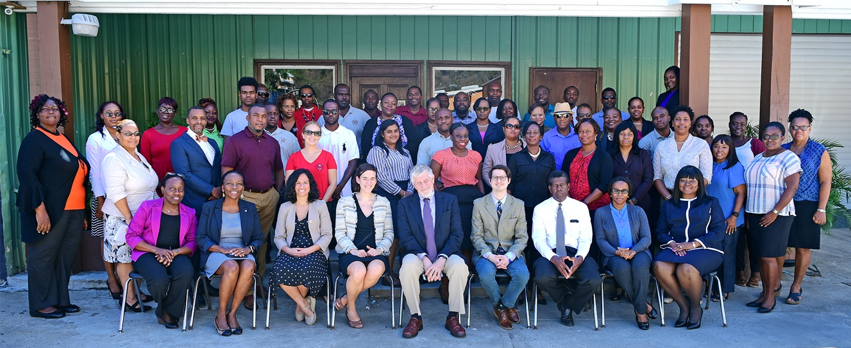

Background
The government of the British Virgin Islands identified mental health as an important component of disaster recovery following the hurricanes of September, 2017. They arranged with PAHO and the Global Mental Health Program of the Department of Psychiatry and Behavioral Sciences at the George Washington University to conduct a Resilience Building workshop for medical and community leaders.
We conducted a 2 ½ day workshop 4-6 February, 2019 in Road Town, Tortola, British Virgin Islands, to provide training to build skills in these areas: Psychological First Aid (PFA), mindfulness techniques, Hope Modules and Compassionate Listening in response to loss and disaster. In the initial phase of these workshops, participants engaged in learning self-care applying these three core skills. Goal is for participants to learn techniques for applying these skills in caring for others, caring for self, then caring for others in a cascade model.
Additionally, we conducted evening sessions 4 and 5 Feb. at Peebles Hospital for medical staff and private sector people.
Faculty
Allen R. Dyer, MD, PhD, Professor of Psychiatry and Behavioral Sciences, GWU
Vanessa Torres-LLenza, MD, Assistant Professor, GWU
Jacqueline Posada, MD, 4th year resident in Psychiatry, GWU
Jeremy Safran, MD, 2nd year resident in Psychiatry, GWU
Objectives
- To mitigate stress, burnout and vicarious trauma
- To build the capacity of health care providers in self-care and to build resilience to the impact of disasters
- To provide practical skills in helping others cope with challenges in their lives following disasters.
Skills taught:
- Psychological First Aid (PFA) is a standard intervention for humanitarian emergencies, a specific skill that does not require a professional training.
- Mindfulness training is a set of behaviors and exercises that mitigate stress by countering the body’s fight or flight response with rest and relaxation counter-measures, such as awareness of breathing exercises, relief of muscle tension, and paying attention to thoughts that may exaggerate tensions.
- Hope modules are a series of strategies, developed at The George Washington University for dealing with the psychological impacts of acute and chronic illness, and now being applied to humanitarian emergencies. Hope modules focus not on feelings, but rather on behaviors, something that one does or learns to do, relying on coping skills that have already been acquired.

Summary:

Day 1
Training began with an official ceremony by Chief Medical Officer of the Ministry of Health, Dr. Irad Potter. In his opening remarks, he commented that when the Ministry of Health gathered in the days after Hurricane Irma, he realized that the inhabitants of the British Virgin Islands were not prepared for “living through or living after a disaster.” He expressed his goal of the workshop for the group as 2 days to preparing leaders, both emotionally and intellectually, to respond to future disasters. Dr. June Samuel Director of Medical Services, British Virgin Islands Health Authority presented an overview of mental health services in BVI. To start the didactic Dr. Claudina Cayetano presented on General Framework for disaster management.
Activities included didactic sessions on disaster and emotional response to disasters:
- What is stress? What is resilience? Communities impact during disaster
- Defining Vicarious Trauma and its impact on individuals and the community
- Introduction to Mindfulness Based Stress Reduction (MBSR) and practical skills
- Trauma, Post Traumatic Stress and Burnout
- Adverse Childhood Events
The participants were introduced to the workshop website on Day 1 as they were asked to complete the pre-test and optional scales using the website.
The workshop included group discussions and interactive activities following many of the didactic sessions. Below are descriptions group discussions, the interactive activities and participant insights and feedback to the activities.
Group Discussion about emotional response to disaster: The presentation covering community response to disaster generated active group discussion about an image showing phases of disaster which outlines the emotional responses that throughout disaster response. Many participants felt stuck in the disillusionment phase as many services, such as businesses and tourism, have returned to normal, however many people still dealing with the physical and emotional consequences of the hurricane and disaster response. From the evening session with health care professionals one nurse remarked, “...parts of the island have been physically reconstructed, so it looks like the island is recovering. This chart makes me think we have not emotionally recovered from Hurricane Irma so I feel disillusioned.”
Vicarious trauma: The participants were broken into four small groups and each group was asked to discuss one of the following topics: 1) Who experienced vicarious trauma? 2) identifying signs of vicarious trauma (physical and behavioral symptoms), 3) impact of vicarious trauma on relationships 4) Impact of trauma on the workplace including dynamics between management and employees as well as between employees.
The groups identified with the concept of vicarious trauma and community trauma. Participants reflected on what it was like to live and function on the island when every person was impacted by the hurricane. Participants did not identify many physical symptoms of trauma and vicarious trauma, focusing instead on behavioral changes and impact on self and community. One participant who worked at a shelter after the hurricane reflected that she had not realized she was experiencing vicarious trauma until it was defined in the presentation. Group 3 who discussed relationships tended to reflect how relationships grew closer after the storm and started a conversation about vicarious resilience. Many families were brought closer together by the storm as family units sought each other out in the immediate aftermath of the storm and then stuck together survival and comfort. Neighbors and people who had not talked in the past checked in on each other after the storm and families staying together in the shelters supported each other while in shelters and kept in touch after. These strengthened relationships persisted after the storm as people reflected that community relationships and vicarious resilience are intrinsic resources for survival and recovery. Group who discussed the impact of trauma on workplace talked about how it was difficult to perform at work when employees were at varying levels of functioning at work due to the physical and emotional impact of the storm. For example, some employees were irritable, tardy, or even absent, but it felt difficult to help each other without clear communication about personal issues. Many employees felt targeted by employers and felt that management was not flexible in their demands given the impact of the hurricane. Group 4 reflected that without training on impact of stress, trauma and identifying burnout, it is difficult to help each other emotionally after the storm.
Mindfulness Skills: On the pre-test, 65% of respondent reported exposure to mindfulness skills. As an introduction to mindfulness, Dr. Dyer led the group in a brief biofeedback exercise in which they measured their pulse, then were led through a deep breathing and guided imagery exercise, and then asked to retake their pulse. Most participants acknowledged their pulse was lower. After a didactic introducing mindfulness and the overlap with resilience factors, the large group participated in two mindfulness skills activities of mindful eating using a raisin and mindful pausing.
In mindful eating, participants were asked to move slowly through the following phases of eating a raisin: holding, seeing/looking, touching, smelling, placing raisin in the mouth, chewing, swallowing, noticing after effects. Throughout mindful eating there was a lot of laughing and dubious looks to the idea of taking several minutes to eat one raisin. One man commented, “I was thinking, “Why are we going so slow? This is ridiculous.” Then I realized that was the point and I wanted to slow down other parts of my life.” Other comment related to the how normally people eat without thinking and it was useful to pause and think about urges to eat the raisin immediately, chew, swallow and move on to the next raisin. The group was able to identify places in their life where it would help to slow down, and the facilitator reviewed how slowing down is a key component to changing stress related behaviors. We reviewed the schematic of how stress can cause a reaction without thinking but pausing and thinking allows for a response to stress and helps an individual feel in control.
Next the group was introduced to the concept of mindful pausing using the STOPP technique and technique was practiced as a group. Participants were given homework to use mindful pausing at least once in the evening before day 2.
- Stop - Pause from you are doing for a moment
- Take a breath (or two)
- Observe what is happening without and around you. Notice physical sensations, thoughts and emotions
- Purpose - What is your purpose? Right here and right now.
- Proceed - Given your purpose, what needs to be done?
On day 2, the participants were asked to reflect on mindful pausing. One participant noted that he used mindful pausing while praying and form him it was useful to merge these two stress relief skills. While praying he was able to pause and listen to what God might have to say to him. Another participant noted that she used mindful pausing while taking a walk on the beach and it helped her identify that her mind was still consumed by other topic and tasks. Mindful pausing helped her connect with the peaceful moment she wanted to have taking a walk. One woman reflected that she did not use mindful pausing until 3am when she woke up feeling anxious. She was able to use the STOPP technique to evaluate how she was feeling and able to fall asleep feeling calmer. The mindful pause allowed participants to reflect on how their minds are consumed with normal concerns and continued worries and tasks related to Hurricane Irma and gave them a chance to reflect on how their mental energies are used.

Day 2
Hope Modules and Hope Mobilization: The Hope Modules and Hope Mobilization is a form of brief psychotherapy that focuses on behaviors and adaptive coping skills developed at the George Washington University. Hope Modules is a (one conversation) transdiagnostic intervention meant to target demoralization, a sense of subjective helplessness that arises in the face of chronic stressors. The hope modules teach “hope mobilization” by helping a demoralized individual reflect on a difficult time in their life and identify a signature adaptive coping strategy that has gotten through previous adversity. The workshop compared depression to demoralization and then explained the 4 domains of hope mobilizing techniques including problem solving and goal seeking, relational coping, activating a core identity, and emotional regulation. A clinical case was used to illustrate how hope mobilizing can be used outside of a therapeutic relationship. Hope is identified as a practice, not only a feeling. The goal of teaching the hope modules and hope mobilization is to help participants recognize how they maintained resilience during the aftermath of the storm and discover their own hope mobilizing capabilities by encouraging them to recount their most challenging days of Hurricane Irma.
After the Hope Modules didactic session, participants were paired up in group of 2-3s to discussed challenging time to identify which hope mobilizing skill they used during that time. Examples from participants.
The interactive Hope Modules session was the most emotionally vulnerable part of the workshop as participants talked with each other about living through the hurricane and the immediate aftermath. Below are a few examples some of the stories told. The GWU facilitators helped the participants identify the hope mobilization skills used to overcome their adversity.

Ms. X recounted she has lived through three catastrophic hurricanes. She shared how she spent hurricane Hugo on the island of St. Thomas. She was initially afraid of the storm and then “In St. Thomas, I went to family’s house who had built his home like “A Tortolian.” During the Hurricane Irma, she said she and her family stayed in a closet and, “we prayed with the kids and sang with them to keep them calm.” After the storm, her kitchen was remained intact, so she was able to cook for her family and her neighbors. She concluded that she believed in Tortola’s hope to rebuild and she knows she can get through the recovery period by depending on the community and God.
After she told her story, the GWU facilitators led a discussion of what Hope Mobilizing strategies used:
- Problem solving, Agency thinking: She and others carry the overarching belief that the island must rebuild.
- Activating a Core identity by taking pride in her identity as an islander from Tortola who can survive hurricanes and rebuild.
- Emotional Regulation: Using prayer and song to keep calm during the storm.
- Relational Coping: Altruism as she reached out to family and neighbors and provided food as her kitchen was intact. Being with family and neighbors during the period of hardship.
Ms. Z recounted her intense anxiety about the islands being hit by a category 5 hurricane even before Hurricane Irma hit the islands. She experienced such panic before the storm that she was having memory issues and confusion. She went to the store for provisions forgot flashlights and batteries. She fears thunder and lightning and kept her hands on her ears the whole hurricane. During the storm, she worried that her cousin had died inside the wooden house he lived in down the hill. After the storm, she didn’t leave her house for several days saying “I didn’t want to see that this was Tortola.” The woman cried as she told her story to the group. When asked to explain how she managed to recovery she said she had to get out of her house to find the rest of her family, care for her immediate family and to be in contact with her church community that helped her feel closer to God.
- Relational Coping: A desire to be with family and care for them helped this woman overcome her distress after the storm.
- Activating a Core identity: This woman activated her identity as a member of her church community (separate from faith in God) and she left her hope to rejoin this community.
Nurse A’s turned 50 years old the day Hurricane Irma hit Tortola. She had planned to take a vacation with her family for her birthday but was unable to leave. Most of her family had left the island for both vacation and evacuation, so she was left alone in her home during the hurricane. As her house was destroyed, she sought shelter behind a refrigerator with a pan over her head. One the storm had passed, she felt alone, so she made her way to Peeble’s Hospital where she knew people would be gathering. Even though she was not scheduled to work, she signed up to work shifts that very day. The hospital created temporary shelter for medical staff to sleep as they worked alternating shifts. Nurse A explained show she was able to overcome sadness and anxiety by working in the Emergency Department, and that keeping busy ministering the patients in the ED made her feel useful and forget about her 50th birthday. She felt a close bond to the other medical staff who stayed in the hospital the month after Hurricane Irma and says her work allowed her to cope with the aftermath of Hurricane Irma.
- Relational Coping: Altruism and ministering to patients who were impacted by the storm helped restore hope. She also depended on her relationships with fellow medical staff
- Activating a Core identity: Stepping into her role as nurse and medical provide allowed Nurse A to feel empowered in the face of disaster.
Mr. B is a member of local government on Virgin Gorda who had access to a satellite phone after the storm. He identified with the confusion and anxiety after the storm as the island was destroyed and cut off from the rest of the world. He said once the storm cleared, it was difficult to dial out using the satellite phone, but he was able to get in contact with an NGO who posted his satellite phone number on Facebook. He was elated when he started to get calls IN to the phone. He said family members in the US and UK were calling the phone to check in on family members. He recounted how someone from embassy of Venezuela called to check in about an aid group staying on Virgin Gorda. He was able to tell the embassy representative that the group was displaced but safe as he had seen them walking down the street. He was able to tell many people who called that their family members were safe and alive. He said, “I can’t tell [the family members] where they are, but I could tell them they are safe.”
- Problem solving-Pathways thinking: Mr. B identified a need to get in contact with the outside world by using his satellite phone, but he was unable to call out. He problem solved by calling an NGO and getting the phone number posted, which opened up lines of communication to Virgin Gorda. He stayed on the phone and took messages from people calling.
- Relational Coping-Altruistic relationship: Mr. B was visibly moved as he recounted his role in relieving the fears of family members by reassuring them that citizens of Virgin Gorda were alive and well. He used this helping capacity to maintain hope that allowed him to cope in the immediate destruction of Hurricane Irma.
Many others told their stories about surviving Hurricane Irma. The participants had diverse hope mobilizing strategies, however a few stood out.
Relational coping: Often, depending on others for help is a “weakness.” So in this portion of the workshop, GWU facilitators emphasized this relational coping as a skill to be mobilized in future adverse events. Below are the subtypes of relational coping that were mentioned most frequently.
- Attachment relationships: Many participants spoke about relief and sense of hope restored when they found their family members on the island or got in contact with people all off the island. Many spoke about how they felt at their most hopeless when the lines of communication where down, the roads where cut off, and means of transport were destroyed.
- Social network: When individuals could not find their families, they turned to neighbors as a means of support.
- Altruism: This relational coping was particularly prominent in health care providers who discussed their desire to get back to work to take care of people on the island. Participants of the daytime workshops also utilized altruistic relationships as coping by helping family, neighbors, and strangers in times of need.
Activating a Core Identity:
- Collective identity: Being an islander who can survive a hurricane
- Family identity: identifying as part of a family and needing to band together to survive
- Personal identity: People identifying as a strong person who will get through this time
Problem Solving-Agency Thinking: Many participants spoke about an underlying belief that “we will get through this” or “we will rebuild.” By activating this overarching belief in recovery, they were able to expand to other skills and planning to get face adversity.
Emotional Regulation: Prayer and contacting family members were the most commonly used emotional regulation techniques.
Compassionate listening was introduced and examples of counterproductive listening were provided. Didactic activity of life mapping done and mapping exercise done among groups.

Day 3
Psychological first aid
Personal goals
Organizational goals
Group reports

Preliminary Results
Audience engagement, participation
Verbal feedback during sessions
Pre and post-tests: The workshop pre-test had 62 individual responses and an average score of 6.95 / 15 points. Frequently missed questions included: 1. Which of the following ethical principles is NOT in the Hippocratic Oath? (18% correct) 2. What is the smallest unit of health? (30% correct) 3. Which of the following is an inevitable stage of grief or loss? (36% correct) 4. What is one component of the traditional definition of professional burnout? (36% correct)
The workshop post-test had 54 responses and an average 10.23 / 15 points. Notable improvement was noted in the frequently missed questions. 82% of respondents answered correctly about parts of the Hippocratic Oath, 91% of people responded “community” as the smallest unit of health, 55% identified anger as an inevitable stage of grief, and 93% identified cynicism as a component of the traditional definition of professional burnout
Feedback form: The end of workshop feedback form received 20 responses. Of the 20 individuals, 95% would recommend this workshop to a friend. The evaluations were based on a 1 to 4 Likert scale ranging with 1 signifying strongly disagree and 4 signifying strongly agree. The response to the workshop was overwhelmingly positive as 100% of respondents agree to strongly agree the workshop was relevant and the was a good mix between listening and activities 90% agree to strongly agree the workshop was comprehensive and the online workshop materials were clear and well organized.
Comments provided useful feedback to tailor the follow up experience to the participants needs.
What worked? When asked was participants like the most about the workshop, many people responded “interaction” with the mix of sectors and the instructors. One participant commented, “I liked hearing the other groups reporting on how they dealt with situations and how individuals experiences of the hurricanes were but most of all how we incorporated the techniques learnt.” Another commented, “Everything!!!! It was very interactive workshop and allowed me to see what/How others view each situation and identifying the similarities we all have in responding to things.”
What could be improved? Several respondents identified the room as too cramped for small group activities. Others commented they would like more opportunity to practice the skills presented. Two commenters enjoyed the material presented but felt pressured by the role of representing their sector/office and being expected to teach back much of the information to colleagues.
Comments from the section, “Would you recommend this workshop to others? Why or why not?”
Positive:
“So they can learn how to incorporate what they already know in an effective way.”
“I would recommend this workshop to other people because it will enable them to be supportive to others and learn how to cope with their own emotions and stressors while doing so.”
“Informative and beneficial in having persons exposed to non-intrusive psychosocial support that is beneficial in various settings.”
“I think it would also benefit other first responders as well.. CERT teams, more fire officers from Sister Islands and even police.”
“I think it's relevant to suit our busy lifestyle in disaster situations.”
“This workshop should be done across the Caribbean. Especially in those Islands which experience natural disasters.”
Neutral to negative:
“I would recommend it for someone who does not already have the skills “discussed”. For those of us who already have these skills, I would prefer more practice/activities.”
“I found that the training was properly timed out. But having a manual to read before or even to follow along. And some tables be able work in groups better.”
“This workshop could have been improved if the intention, outline and activities were better explained prior to execution.”
Blog

Next steps/Follow up
Team will return in ~6 months for review of core skills and more in depth experience.
Dr. Potter charged the participants to make these skills part of their on-going life and work and to take them back to their organizations and communities.
Each participant was invited to identify a personal goal and a goal for their organization and to monitor progress and report back at the follow up session in six months (August, 2019)
Additionally, we are exploring the possibility of periodic webinars in the intervening months.

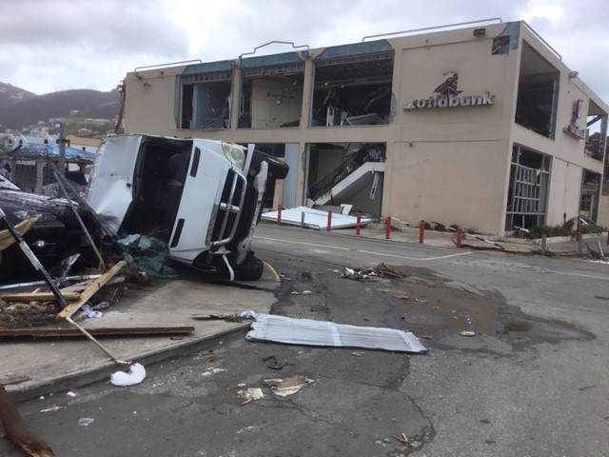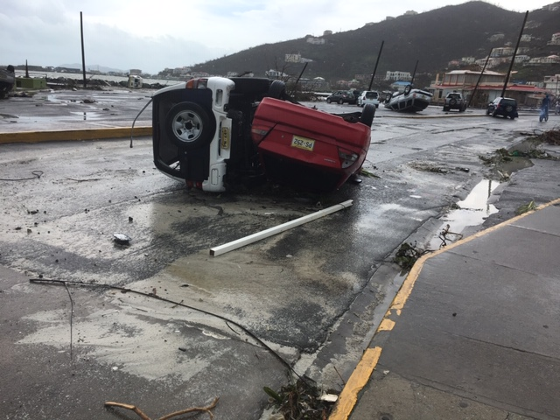
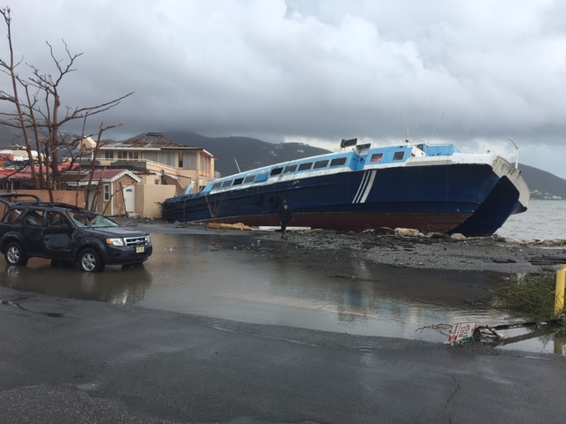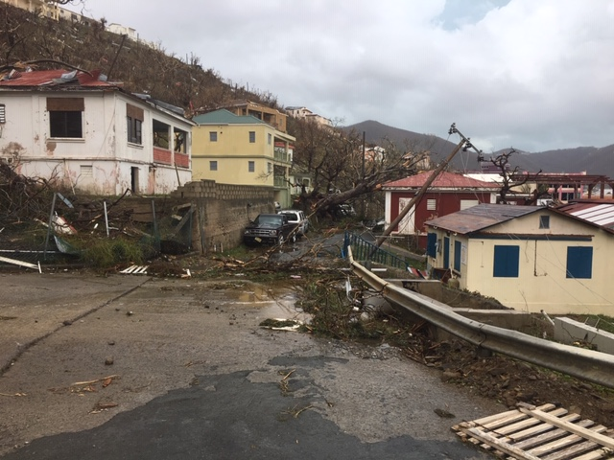
Photos courtesy of K Buring.

Shirley Vanterpool says (comment on the webpage):
February 6, 2019 at 11:52 pm
This was a very inspirational, much needed and informative workshop. Thank you for the opportunity to participate and I look forward to the next scheduled sessions. In the meantime, I feel better prepared to deal with daily stressors and am willing to pass on the knowledge and skills to others who may benefit as I feel that I have.
Thanks again.
Shirley

