Narcissism and Narcissistic Rage:
Ahab on the Couch

Allen R. Dyer, MD, PhD
Department of Psychiatry
and Behavioral Sciences
The George Washington University
October 5, 2015

Herman Melville’s novel Moby Dick gives us one of literature’s most memorable characters, Captain Ahab. Ahab pursues his obsessional revenge to kill the white whale that has “dismasted him”. It is a complex story, metaphorical at many levels, not the least of which is the portrayal of a destructive leader, whose pursuit of his own goals ends badly for all in his orbit.

For our purposes, Moby Dick offers a compelling character study of the narcissistic personality, its origins and its consequences. Personality disorders are usually thought of negatively, either because of their impact on others or of the difficulty in treating them. Understood developmentally, we may be able to develop some empathy with those who lack empathy for others.

DSM-5 criteria for narcissistic personality disorder
a pervasive pattern of grandiosity (in fantasy or behavior), a constant need for admiration, and a lack of empathy, beginning by early adulthood and present in a variety of contexts, as indicated by the presence of at least 5 of the following 9 criteria:
- Having an exaggerated sense of self-importance
- Expecting to be recognized as superior even without achievements that warrant it
- Exaggerating your achievements and talents
- Being preoccupied with fantasies about success, power, brilliance, beauty or the perfect mate
- Believing that you are superior and can only be understood by or associate with equally special people
- Requiring constant admiration
- Having a sense of entitlement
- Expecting special favors and unquestioning compliance with your expectations
- Taking advantage of others to get what you want
- Having an inability or unwillingness to recognize the needs and feelings of others
- Being envious of others and believing others envy you
- Behaving in an arrogant or haughty manner

DSM-IV and DSM-5
Criteria for the Personality Disorders

DSM-IV | DSM-5
- An enduring pattern of inner experience and behavior the deviates markedly from the expectations of the individual's culture.  - The enduring pattern leads to clinically significant distress or impairment in social, occupational, or other important areas of functioning. | - Significant impairments in self (identity or self-direction) and interpersonal (empathy or intimacy) functioning.

REVIEW OF KOHUT’S CONTRIBUTION TO UNDERSTANDING NARCISSISM AND NARCISSISTIC RAGE

Heinz Kohut published Analysis of the Self in 1985 and it has proved to be one of the most seminal books on psychoanalytic technique in the latter half of the 20th century. It opened up to consideration some of the most difficult aspect of psychodynamic treatment, namely the personality disorders. Freud’s formulations of Oedipal dynamics operate within the realm of language, pre-Oedipal conflicts (dependency, control, trust) often must be inferred from behavior and affects.
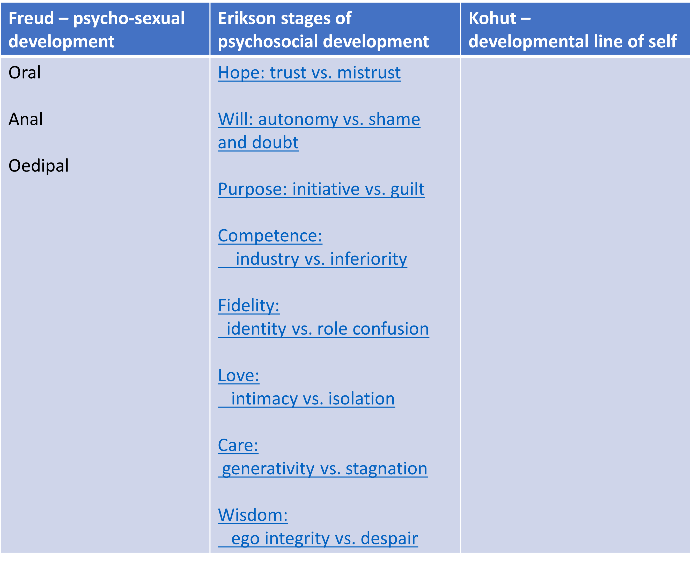

Kohut postulated a separate developmental line of self and its understanding came to be known affirmatively as “self-psychology” His writings were thus particularly useful in understanding the kinds of problems that presented to psychiatrists in the latter half of the 20th century, not so much symptom neuroses, hysteria, hysterical dissociation, phobias and compulsions, but character neuroses and particularly what we have come to understand as problems of narcissistic pathology, simply disturbances of “self”.

Kohut’s theory has helped us to listen more closely to those particular kinds of disturbances that are so difficult to stay attuned to in long-term therapy, when we the therapists are consistently ignored as people in the sessions. Kohut’s work has helped us ascribe an affirmative attitude to the problems of narcissistic pathology, which are usually met with reciprocal prejudice and devaluation.

And finally, Kohut has helped us by describing and providing a phenomenology for a particular kind of anger and aggression, namely narcissistic rage.

NARCISSISTIC RAGE

Kohut suggests that we include in the term narcissistic rage all the points on the spectrum of experience that reaches from such trivial occurrences as a fleeting annoyance when someone fails to reciprocate our greeting or does not respond to our joke to such ominous derangements as the furor of the catatonic and the grudges of the paranoiac.

The various forms of narcissistic rage share a specific psychological flavor: the need for revenge, the righting a wrong, for undoing a hurt by whatever means, and a deeply anchored, unrelenting compulsion in the pursuit of these aims which gives no rest to those who have suffered a narcissistic injury. These features of narcissistic rage set it apart from other kinds of aggression.

In biological terms, we easily observe that the narcissistically vulnerable individual responds to actual (or anticipated) narcissistic injury either with shamefaced withdrawal (flight) or with narcissistic rage (fight).

CAPTAIN AHAB
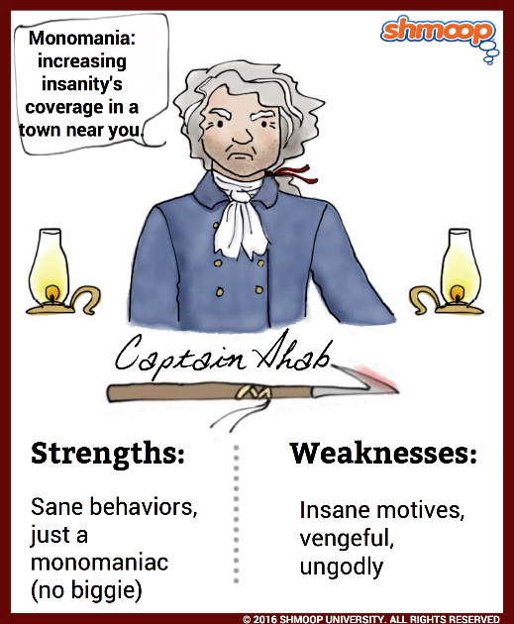
Melville’s Moby Dick is a pre-eminent discussion of narcissistic process. Captain Ahab is the classic example of a man in the grip of interminable narcissistic rage. Captain Ahab has lost his leg in a previous encounter with the white whale and is determined to avenge himself no matter the cost. Why, one might wonder, can Ahab not grieve the loss, accept his fate, and his peg-leg prosthesis and enjoy a life though perhaps somewhat diminished, no longer his whole self? But still he has a ship’s command, a wife at home, the prospects of a successful whale hunt and all its rewards. The injury is not just a physical one; it is also an assault on his sense of self, his sense of who he was.

Ahab’s obsession is not a justifiable reaction to the transgression of the whale, but rather a manifestation of a disturbance of his personality, which predated his encounter with the whale.

In Ahab, we witness a total lack of empathy for others. When the ship Pequod encounters the ship Rachel, whose captain is searching for his own son, swept overboard in a storm, Ahab asks only if the captain if he has seen the white whale, then hastily departs in his obsessional pursuit.
In Ahab, we see ethical tension between pursuit of his own goals and obligations to others, his crew, the owners of the ship, and in the case of the Rachel, to others in distress. We may formulate this tension the tension between perfectionistic ideals and human possibility, the difference between the aspirations and human limitations or in psychoanalytic terms, the difference between the ego ideal and the super ego.
Thus, we see in the development of a sense of self, the impetus to be moral, not selfish, either by internalizing the ideals of our parents and society (the ego ideal) or by accepting the norms and prohibitions of our culture (the super ego).

It is I think through an understanding of the ego ideal that we come to be empathic with the vulnerabilities of the self, that we come to be able to deal with narcissism and a host of pre-oedipal issues.
Narcissism is born of an effort to restore the lost pleasures of the symbiosis with an all-giving mother. In this blissful state, the human infant lies securely at the center of his universe. His every need is met by the mother (or sometimes another) who needs him almost as much as he needs her. He is omnipotent. If he is hungry in some other way uncomfortable, he cries, and the mother comes to meet the need. This state is referred to as primary narcissism, but it is a precarious condition.

The enemy of primary narcissism is the reality principle. The symbiosis is ruptured too soon after the infant is expelled from the womb. He is hungry and cries, but the mother does not immediately appear. The universe is not perfect as he had imagined, and it is not under his control. The result is rage, possibly despair, if he is abandoned or if the parent is not dependable. The original sense of omnipotence has received the first of many “narcissistic injuries.” Reality has entered in.

In other words, narcissistic personalities are created either by too much parental attention or too little. The dilemma of each conscientious parent is how much frustration can the infant tolerate and when. If primarily narcissism persists too long the infant is indulged and always expects more; if the infant is neglected, it feels deprived, enraged and legitimately entitled.

The infant copes with the intrusion of reality by shifting focus to an idealized parent; it is not he but the parent that is perfect. As the infant’s physical and mental abilities, particularly locomotion, develop, it is less necessary to be completely dependent on the parent and the infant becomes aware of its separateness.

The small, helpless infant forms an ideal of what he would like to be like, namely omnipotent like the parents. But even under the best of circumstances, the idealized parents prove fallible, incapable of providing the total gratification remembered from earliest infancy, and the infant develops a new and better possibility for the self, the ego ideal. The love which was originally invested in the self, then the idealized parent, is now invested in the ideal self that he desires to become. This state is called secondary narcissism.

Freud observed that man creates ideals for himself, such as political causes, Marxism, Nazism and religious causes, in order to restore the lost narcissism of childhood, to restore that state of contentment in which one’s needs are passively met. It is the ego ideal, Freud claimed, “by which the ego measures itself, towards which it strives, and whose demands for ever-increasing perfection it is always striving to fulfill.” But the grandiose aspirations for perfection can never in reality be fulfilled. A person’s sense of self-esteem is determined by the distance between his actual self, his strengths, talents, abilities, and accomplishments, and his ego ideal.

Even in our brief therapies, we see our patients struggle in frustration with perfectionistic ideals, impossible to achieve. I call this the “Washington syndrome” and have coined a new word to describe this condition: “hyper-conscientiousness.”

The superego, thought to be distinct from the ego ideal, is a developmentally later acquisition. In contrast to the ego ideal, which lures the person on to higher and often impossible standards of perfection, the superego is restrictive. It is the superego that is the internalized representation of the parents’ and the culture’s standards for conduct. The superego is the unconscious conscience that criticizes the id impulses and keeps the ego in line. Instinctual gratification (whether sexual or aggressive) is renounced either out of fear of loss of love by the ego ideal or fear of punishment by the superego. This is why Freud suggests in Civilization and its Discontents that neurosis is the price we must pay for the harmony of civilized culture.

Ego ideal  (Mona Lisa) | Horological  (heavenly ideal) | Omote  (front) | Tatemae  ridgepole | Pride/shame
Super Ego  (Simon Legree) | Chronometrical  (Earthly time) | Ura  (back) | Hone  self | Guilt

TRANSFORMATIONS OF NARCISSISM

- Creativity
- Empathy
- Humor
- Wisdom
- Finiteness of life

Kohut’s theory derived from the re-analysis of people who had had unsuccessful or incomplete first analyses. He noted that these people developed one of two kinds of transferences, idealizing transferences, in which the analyst was seen as all-wonderful, and mirroring transferences, in which the analyst mirrored the grandiosity or insecurity which the patient was experiencing. In both situations, the analyst must be able to sustain empathic contact, even when the idealizations are followed—as they inevitably are—by devaluations or when the empathic mirroring is imperfect—as inevitably it is-- triggering a primitive rage. It is thorough the acceptance and understanding of this rage, entitlement, devaluation that growth can occur. It is through the precious moments when empathic understanding is imperfect, that the patient can come to understand that patient and doctor are separate people, with separate experiences, and not mirrors of each other.

In narcissistic characters, which is to say, in most of us at various times, employing defenses against narcissistic disappointments, the belief is that the present reality is unpleasant because of the fault or shortcomings of someone in the present situation, the spouse or mate, the teachers, the boss, the analyst. If only these people would change, then things would be better. The analyst must accept these distortions as a wish and accept the rage which accompanies them. Then calmly and persistently point out that the feelings are rooted in history, in a history that may be preverbal. It is at this point that grieving can occur as the patient gives up as a loss the wish that had been held throughout life. Depression sets in, not as a symptom to be eradicated, but as a signal that the therapeutic process is working, memory has been activated, and reality is accepted for what it is rather than for what one might wish it to be.

THE CONCEPT OF CHARACTER: MORAL AND THERAPEUTIC CONSIDERATIONS

It its efforts to remain a-theoretical, the DSMs refer to personality disorders rather than character disorders. What we have are descriptive lists of symptoms with little utility in their meaning. There is a rich tradition in psychoanalysis in understanding character structure, dating back to Sigmund Freud’s descriptions of character types--the hysterical character, the obsessional character, the paranoid character-- Wilhelm Reich’s understanding of “character armour” and especially Anna Freud’s brilliant work in elucidating mechanisms of defense. Narcissistic personalities are as much about vulnerabilities as they are vanity.

- noun, Psychiatry.1.a disorder characterized by socially undesirable behavior, as poor control of impulses or inability to maintain close emotional relationships, and by absence of anxiety or guilt. Random House 2017
- character disorder n.
Any of a group of personality disorders characterize by a persistent pattern of maladaptive behavior, emotional instability, immaturity, compulsive gambling, sexual deviation, or alcohol or drug addiction
American Heritage® Stedman's Medical Dictionary
Copyright © 2002, 2001, 1995
- The diagnosis of character disorder is accepted generally as describing an individual whose behavior disturbances bring him into conflict with his immediate environment or society at large Random House Dictionary

The same word “character” occupies a central position in the lexicon of moral philosophy. While psychotherapies are overtly value-neutral or at least non-judgmental, moral philosophy is explicitly reflective on value judgments. While ethics is often framed in terms of either/or dilemmas, moral philosophers are increasingly interested in the question of character and the virtues. What kind of person do we wish to be? What kind of person do we wish to become?

So the word “character” operates at many levels simultaneously. At one level it means simply characteristic, the traits that are characteristic of a particular individual. That is just like Mary. John walks just like his father. In psychoanalytic therapy, character may function as a resistance, the defenses one characteristically uses to avoid re-experiencing painful memories. As a therapeutic technique, the therapist allies with the part of the self that wants to get better, and tries to drive a wedge between that part of self against the part that wants to hold on to old maladaptive ways of being.

Psychoanalytic clinicians have always taken a seemingly contrary stance toward their patients’ descriptions of their problems. If the patient describes ego-alien symptoms, the therapist attempts to demonstrate that the symptoms are not really alien but reflect coconscious themes central to his mental life. On the other hand, if the patient presents ego-syntonic character pathology, the analyst spends a great deal of time trying to weaken the patient’s unquestioning acceptance of those charter patterns by driving a wedge between the character pathology and the part of the patient that is capable of self-observation. The attempt is to make character defenses ego-alien. Always interpret the resistance before the content.

TWILIGHT OF AMERICAN SANITY

Captain Ahab is emblematic of a president whom many consider mad and dangerous. Whether or not he is mentally ill is a subject worthy of debate. Allen Frances, once described by the New York Times as the most influential psychiatrist in America for his role as chair of the DSM-IV task force, argues on CNN interviews, a recent New York Times op ed, and in an important new book, Twilight of American Society: A Psychiatrist Analyzes the Age of Trump, that the president is not mentally ill because he does not meet criteria for personality disorder because his symptoms do not cause him distress. Frances’ argument is that Trump is bad, not mad. The problems that concern us are moral and political, not a result of mental illness. Frances notes that “It is comforting to see President Trump as a crazy man, a one-off, an exception—not a reflection on us or our democracy. . . What does it say about us, that we elected someone so manifestly unfit and unprepared to determine mankind’s future? Trump is a symptom of a world in distress, not its sole cause. Blaming him for all our troubles misses the deeper, underlying societal sickness that made possible his unlikely ascent. Calling Trump crazy allows us to avoid confronting the craziness in our society—if we want to get sane, we must first gain insight about ourselves. Simply put: Trump isn’t crazy, but our society is.”

I agree with my friend Allen Frances that the real objection to Trump’s behavior is moral impairment not mental distress. It would be too easy to say, he is not culpable by reason of mental illness (not guilty by reason of insanity.) I am concerned, however, that the tick-box check lists of the recent DSMs with their either/or approach – the light switch is on/the light switch is off – misses the nuance that I have tried to elucidate here in understanding how character defenses work.

THE SO-CALLED GOLDWATER RULE
Since the election of Donald Trump, the APA code of ethics has received more attention than any time since it was first written in 1973. The interest centers on section 7.3, which has come to be known as the Goldwater Rule, which states that “it is unethical for a psychiatrist to offer a professional opinion unless he or she has conducted an examination and has been granted proper authorization for such a statement.” As a member of the APA Ethics Committee when this section was formulated, I remember the discussions from forty years ago. We wanted to proscribe more than offering a diagnosis, and I suggested the language “professional opinion” to encompass the role of ethics in the definition of profession. A profession is more than a trade because it is organized around a code of ethics, in the case of the American Psychiatric Association, that code is the AMA Principles of Medical Ethics with Annotations Applicable to Psychiatry
In the current debates among psychiatrists about the so-called Goldwater rule, some are suggesting the language could be updated. I think it is important to remember that the AMA Principles of Medical Ethics state explicitly that they are principles not rules. The difference is significant in ethical theory because principles require the ethical professional to exercise discerning judgment in a particular context and weigh sometimes competing principles, such as “a duty to warn”. In the early days of the ethics committee, the committee saw its role as education of members of our profession rather than proscribing rules to be followed. I think the Goldwater debates (along with Trumps escalating derangement) are bringing the current ethics committee closer to this tradition. The Goldwater caveat is not a gag order and responsible physicians may well have something to contribute to the understanding of this madness.

CALL ME ISHMAEL
Call me Ishmael.
This, one of the most famous lines in literature, opens Herman Melville’s novel, Moby Dick. His story helps us understand our own:
Call me Ishmael. Some years ago - never mind how long precisely - having little or no money in my purse, and nothing particular to interest me on shore, I thought I would sail about a little and see the watery part of the world . . . . [Whenever I find myself growing grim about the mouth; whenever it is a damp, drizzly November in my soul; whenever I find myself involuntarily pausing before coffin warehouses, and bringing up the rear of every funeral I meet; and especially whenever my hypos get such an upper hand of me, that it requires a strong moral principle to prevent me from deliberately stepping into the street, and methodically knocking people's hats off - then, I account it high time to get to sea as soon as I can. This is my substitute for pistol and ball. With a philosophical flourish Cato throws himself upon his sword; I quietly take to the ship. ]
Should you ever be athirst in the great American desert, try this experiment . . . Yes, as everyone knows, meditation and water are wedded forever.
And, doubtless, my going on this whaling voyage, formed part of the grand programme of Providence that was drawn up a long time ago. It came in as a sort of brief interlude and solo between more extensive performances. I take it that this part of the bill must have run something like this:

Grand Contested Election for the Presidency of the United States
Whaling Voyage by one Ishmael
BLOODY BATTLE IN AFFGHANISTAN

(Remember Moby Dick was published in 1851, not 2001 or 2017.)

The final scene of Moby Dick leaves little ambiguity in the metaphor of finality of the ship of state and its mad captain, testing fate and being tested. The whale rams the ship, the Pequod, which sinks, taking down Ahab, the whole crew, save Ishmael, floating on Queqweg’s coffin, left to tell the tale.

The last part of the ship to sink, caught up in the vortex, is the American flag, the flag of Ahab. It goes down with his ship, which, like Satan, would not sink to hell till she had dragged a living part of heaven along with her . . . and the great shroud of the sea rolled on as it rolled five thousand years ago.

